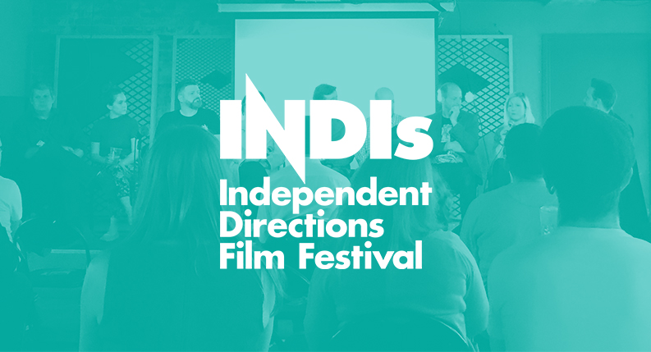
INDIs 2018 Volunteer Form

Volunteer Application Form

Thank you for showing in interest in volunteering for the INDIs. The demand for volunteer places is huge, but the number of places is small. We need people who are:
- Passionate about film, especially independent cinema and emerging filmmakers
- Completely reliable and free for at least two full shifts across three different days from 20th - 22nd July 2018
- Able to work well in a team and on their own
- Driven to help make Leeds Independent Directions Film Festival (the INDIs) one of the best audience experiences in the UK
Please complete this form and email a head and shoulders picture of yourself with your name included in the subject line to sammy.gooch@leedsyoungfilm.com by Thursday 28th June by 17:00.
For more information on Leeds Independent Directions Film Festival (the INDIs) please visit https://www.leedsfilmcity.com/
If you have any queries about volunteering please email Sammy Gooch Operations Coordinator at sammy.gooch@leedsyoungfilm.com
You will hear back regarding your application by the end of Monday 2nd July.
Volunteer Benefits

Volunteers receive the following benefits:
- The opportunity to be involved with the INDIs, and potential future opportunity for involvement in Leeds International Film Festival
- The chance to support the development of emerging talent in the Film industry
- Access to INDIs events across the weekend whilst off-shift
- 4 free tickets to films at Leeds International Film Festival
- A free Leeds INDIs t-shirt
- The opportunity to see the latest in VR technology
- A unique festival atmosphere and the experience of meeting others who love cinema
Volunteer's Meeting

There will be a meeting for all the selected volunteers at 5.30pm on Monday 9th July at Leeds Town Hall, which you must be able to attend. We’re expecting the meeting to last approximately 1.5 hours. If you have been selected, you will hear from us by the end of Monday 2nd July.

Roles

Venue Assistants - These volunteers help to lead on ushering and assisting Venue Coordinators in any way necessary. They may be asked to assist workshops, as well as the INDIs Awards. A passion for cinema and excellent customer service skills are a must.

Festival Runners - Reporting directly to the Operations Coordinator you will be doing a variety of tasks to help the smooth running and operation of the festival. An ability to think on your feet and boundless energy are required. Positions are limited for Festival Runners, we would recommend you apply for Venue Assistant in addition to these roles. You can apply for more than one position.

Application Form

To volunteer for Leeds INDIs you must be over 18 years old to apply. Are you over 18 or will you be over 18 on the 9th July? Please tick (✔):

Yes
No

Which volunteer roles would you like to apply for? You can select more than one position.
Please note Festival Runner spaces are limited. We recommend you apply for Venue Assistant in addition to those roles.
Venue Assistant
Festival Runner

Full Name

Email

Mobile

What t-shirt size are you? Please tick (✔) only one:
Small (fits ladies 8/10)
Medium (fits ladies 12/14)
Large (fits ladies 16+
X-Large

Have you worked as a volunteer for Leeds INDIs, Leeds International Film Festival or Leeds Young Film Festival before? If so, which year(s)?

Why would you like to volunteer for Leeds INDI’s?

Which programme sections of the festival are you interested in? Please tick (✔) as many of the below as relevant:
The INDIs screenings and awards
Emerging technology and virtual reality
Workshops and screenwriting sessions
Networking events
Panel events: i.e. Women in Film, Getting Your Film Seen, Acting and Casting (please specify which):

What experience do you have in customer facing roles and working with the public?

Would you like to hear about other Leeds City Council volunteering opportunities - such as Leeds International Film Festival, Light Night? Please tick (✔):

Yes
No

How did you hear about volunteering at Leeds International Film Festival? *

Availability
You must tick (✔) at least two full shifts on different days across the festival for your application to be considered. The more shifts you are willing to work, the better your chances of being selected. The times indicated here will vary slightly, but this will give us an indication of your relevant availability. If you are not able to start until a specific time, please indicate this in the 'Other' box.

Friday 20th July
9:30 - 14:00
13:30 - 18:00
Other:

Saturday 21st July
10:00 - 16:30
15:30 - 20:30
Other:

Sunday 22nd July
10:00 - 15:30
15:00 - 19:00
Other:

Diversity & Inclusion Monitoring

We are committed to promoting diversity and inclusion. Our aim is for our opportunities to be accessible to all. We would appreciate it if you could complete the equality monitoring questions below. This will help us in monitoring the fairness and effectiveness of our volunteer recruitment.

You are under no obligation to provide the information requested below. However the more information we can collect the more effective our equality monitoring will be. The information you provide will be detached from your application and used for monitoring purposes only.
Please tick (✔) the relevant answers.

Disability: The Equality Act 2010 defines disability as ‘a physical or mental impairment which has a substantial & long term effect on a person’s ability to carry out normal day to day activities’. Please tell us if you consider yourself to have a disability?
Yes
No

Ethnic Origin: Please tell us about your ethnic origin (or tick our closest UK census based category)
Asian/Asian British
Bangladeshi
Chinese
Indian
Pakistani
Kashmiri
Any other Asian background

Black/African/Caribbean/ Black British
African
Caribbean
Any other Black/African/Caribbean background

Mixed/multiple ethnic groups
White & Black Caribbean
White & Black African
White & Asian
Any other Mixed/multiple ethnic groups background

White
British (English/Welsh/Scottish/Northern Irish)
Irish
Gypsy or Irish Traveller
Any other white background

Other ethnic group
Arab
Any other background (please specify)

Gender:
Female
Male
I prefer to self-identify as…
(please write in box)
Please tick if your gender is different than the sex you were assigned at birth:

Sexual orientation:
Bisexual
Gay Man
Gay Woman/Lesbian
Straight/Heterosexual
Other
Prefer not to say

Age range:
Under 20 |  |  | 40-49
20-29 |  |  | 50-59
20-39 |  |  | 60 or over

Religion/Belief:
Buddhist
Christian
Hindu
Jewish
Muslim
Sikh
No religion
Other
Prefer not to say

Thank you for applying to volunteer for the INDIs

Please send this completed form and a head and shoulders picture of yourself* with your name included in the subject line to sammy.gooch@leedsyoungfilm.com by Thursday 28th June by 17:00.
*Please note that as we work with young and vulnerable people, the head and shoulders picture is for security/verification purposes only.

